Development of Energy Education in the Mekong Area (DEEM)
2016-2019

INDIVIDUAL LEARNING JOURNAL

Name:

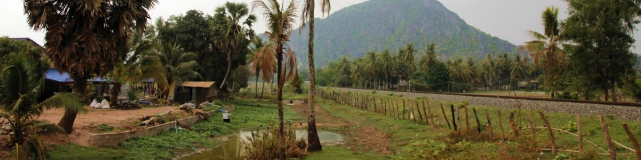

INTRODUCTION
On the basis of the survey results (February 2016) we have come up with a proposed program for the DEEM project. The focus of the program is on didactical skills and curriculum development, combined with examples and issues related to multi- and interdisciplinary sustainable energy education. We plan to spread the program over the 3-year duration of the project, meaning roughly one training visit per year.
During this first visit, we want to touch upon all key elements of the training trajectory such as didactical skills and curriculum development, which we will build upon and deepen during the next three years. In between these training periods, the teachers can practice with their new acquired skills and expertise and share their lessons learned in the follow up training(s). The ultimate goal of the training sessions is to empower professional staff working in the field of sustainable energy engineering education working at Yangon Technological University (YTU), University of Yangon (UY), National University of Laos (NUOL), Institute of Technology of Cambodia (ITC), Royal University of Phnom Penh (RUPP) by creating a learning platform aiming at innovative teaching practices.

Dear participant,

We have developed an ambitious 3-day training, which we will implement with your help efficiently and effectively. Our aim is that you will get the maximum out of this programme in relation to your own personal learning objectives. This means an increase in knowledge, insights, experience and skills, which are as much as possible directly applicable in your own working situation.
In order to improve the applicability of ‘lessons learned’ during the course we have developed some tools, which will help you to ‘translate’ these ideas into your own working situation.

We expect that learning takes place at different levels:
- personal level
  - presentations / lectures: theories, concepts, methodologies, tools
  - ideas & experiences from other participants
  - reading materials / articles
  - course observations
  - personal reflection (daily): writing the personal learning journal
- group level:
  - group discussions
  - group reflections

- The Individual Learning Journal.
You will be requested to fill in your learning needs at the start of the training and use these for personal reference. It is your responsibility to ensure that your personal learning needs are being addressed during the training. Your lessons learned during the training, both in general and in relation to your learning needs, can be described in this journal, on a daily basis, preferably at the end of each day.

Objectives
With the introduction of this Individual Learning Journal we hope to:
- Stimulate your reflection and self-evaluation in a more systematic way.
- Help you to keep track of ideas for your personal action plan.
- Offer you a helping hand for the overall evaluation of the training.
Note: the individual learning journal is for personal use.

Procedure
- At the end of every day, we will give you the opportunity to write down some reflections on the day and use the guiding questions that you see on the next pages.
- At the beginning of each day we will invite participants to share their learning points (particularly what they mean for your work) with the rest of the group.
- At the beginning of each day we will give participants the opportunity to ask for clarification of concepts or ideas, which are still puzzling them.

This individual learning journal can also assist you in making a personal / organisational action plan at the end of the training, and in evaluating the training.

- Reflection sessions
At the beginning of each day we will ask participants to share some of their learning points of the previous day with the rest of the group during the reflection session (15 -30 min.), in particular what implications for change they have concluded from the previous day’s sessions on a personal basis. This will be done by way of a creative presentation or reflection session by the facilitators.

During this reflection session participants can also ask for clarification of concepts or ideas, which are still puzzling them. It is important that you do not just reflect on the programme of the previous day, but particularly on aspects that take your learning a bit further – what are the implications of the lessons learned for you personally / professionally and for your work / organisation?

- Personal action plan
If you really wish to make this training a success and have an impact afterwards we encourage you to start working on a personal / organisational action plan, which integrates your personal learning needs and lessons learned during the training. You will be asked to present your personal action plan on the last day of the course. The action plan should be SMART:

Specific: Well defined, clear to anyone that has a basic knowledge of the project
Measurable: Know if the goal is obtainable and how far away completion is, know when it has been achieved
Agreed Upon: Agreement with all the stakeholders what the goals should be
Realistic: Within the availability of resources, knowledge and time
Time Based: Enough time to achieve the goal, not too much time, which can affect project performance

At page 6 of this learning journal you can make notes for your individual action plan. We suggest that you make a plan that can be achieved within half a year. And make sure the plan can actually be executed by you so it should be within your sphere of work and influence.

INDIVIDUAL LEARNING JOURNAL
Name:

My personal learning needs /objectives at the start of the training:

INDIVIDUAL LEARNING JOURNAL

Date:

General reflections on today’s programme
- What did you personally learn?
- What could be the implications of this learning for you in your work?
- What could be the implications of this learning for your organisation?
- Do you have questions for clarification?

INDIVIDUAL LEARNING JOURNAL

Date:

- General reflections on today’s programme
- What did you personally learn?
- What could be the implications of this learning for you in your work?
- What could be the implications of this learning for your organisation?
- Do you have questions for clarification?

INDIVIDUAL LEARNING JOURNAL

Date:

- General reflections on today’s programme
- What did you personally learn?
- What could be the implications of this learning for you in your work?
- What could be the implications of this learning for your organisation?
- Do you have questions for clarification?

INDIVIDUAL ACTION PLAN

Of what you have learned in this training, are there any thoughts, ideas, actions and decisions on what you want to put into practice after this training:

Topic:

Objective(s):

Action(s) to be undertaken:

Success will be measured by:

Completion date:

